Q1)Please create a database structure for the IPL fixture and results for next year. We have to store the following data in the database
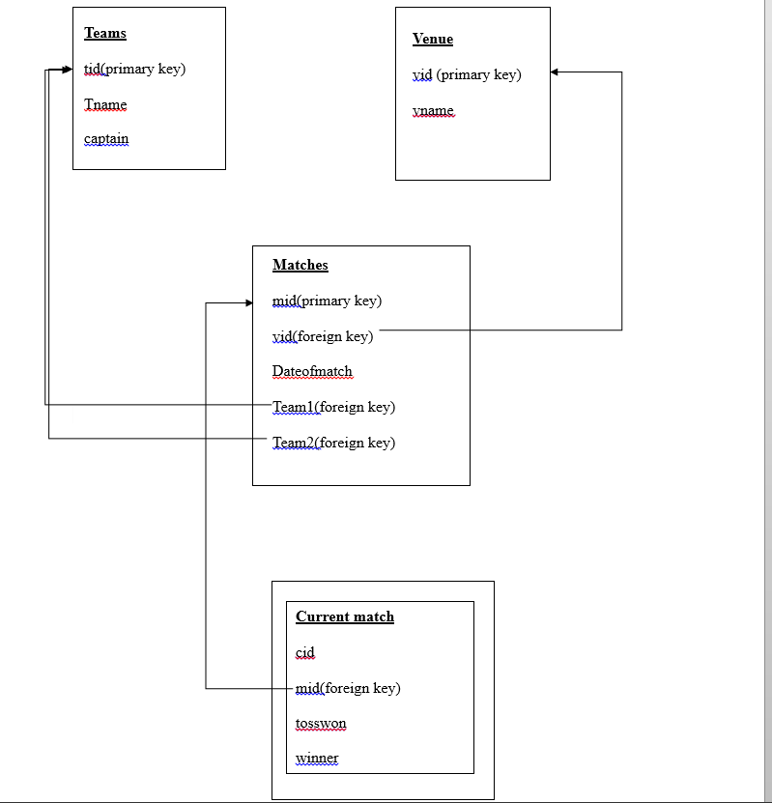

Fig1: relational schema of the database

Queries executed:

1. create table teams(tid smallint unsigned auto_increment primary key,tname varchar(255) not null, captain varchar(255) not null);

2. create table venue (vid smallint unsigned auto_increment not null ,vname varchar(255) not null, constraint pk primary key(vid));

3. create table matches(mid tinyint not null auto_increment , vid tinyint not null , dateofmatch date not null , team1 tinyint not null , team2 tinyint not null, primary key(mid));

a. alter table matches add foreign key (team1) references teams (tid), foreign key(team2) references teams(tid), foreign key(vid) references venue(vid) ;

1. insert into teams (tid, tname , captain) values (2,'delhi','suresh'), (3,'chennai','dhoni'),(4,'bangalore','kohli');

2. insert into venue (vid,vname) values(1,’kolkata’), (2,'chennaisoumi'),(3,'indore');

3. insert into matches (vid,dateofmatch,team1,team2) values (2,'2020-4-04',2,1), (1,'2020-4-05',3,2), values (3,'2020-4-07',4,3);

Description
The database is divided into four relational schemas:
Teams, venues, matches, current match.

The teams schema represents all the teams present in the tournament. Each team has a captain.This schema is referred to get the team names and the name of the captain.This schema only has one primary key and all data’s are atomic.so no redundancy.
Venues schema represents all the venues available for the tournament.This schema also has one primary key and atomic values, therefore no redundancy.
Matches schema represents all the matches which are to be held. Each match has a unique id so even if more than one matches are held at the same date the attributes will have different values.This schema has one primary key mid and two foreign keys team1 and team2 which refers to tid from teams schema.no redundancy as all are atomic values.
All the above three schemas are created before the IPL fixtures.
Currentmatch schema represents the current match stats. This schema provides data about which team won the toss and also won the current match.The data is inserted on this schema during the current match. No other schemas are changed except currentmatch schema
This schema has one primary key cid and mid as foreign key to get the details about the match.All the fields are atomic so no redundancy is present.

